ScDU JSON-LD/SHACL Workgroup – February 25, 2025

Agenda

* Meeting Invites (Today / March 11th)
* Reset on Scope/Objectives

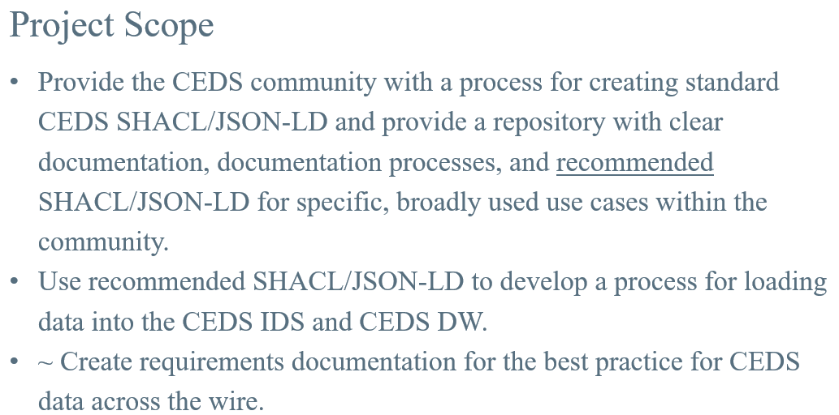

Utilize Gitbook for documentation

* SHACL Generator Requirements
  + Outline of the Ontology
    - Tree Based Selector (select & deselect properties)
    - Checkmark on the properties & classes, provide with a baseline SHACL
    - Any information related to the domains (such as K12, Postsecondary, etc. in the Ontology)?
      * Tree based selector could be rather large – domains could be used to break it down. (This would require going through the file to split items out) (Selector could exist to select one or more domains to include)
    - Search feature
  + Support additional validation
    - Baseline SHACL or the ability to add additional validation in the tool itself
      * Could there be a way to do the tree generator for validation as well. Select & insert additional validation (basic validations such as min/max, regular expressions, pattern)
        + Challenge taking in regular expressions like postal code
    - Determine the validation will be the base shapes file
      * Put it in – easier to leave it out
      * Toggle to add validation or not?
  + Quickly build out base SHACL as a POC, then build out the more advanced UI later.
    - * Would this be pointed at the entire Ontology? In lieu of interface, create a text file and put either Global ID’s or IRI’s and it would build based off that file.
      * Using SHACL libraries (python library is more robust), but in the end, for speed, doesn’t matter what technology is used.
  + Versioning
    - Could be multiple Ontology versions – selector
    - Versioning for the SHACL output
      * Context – version of the Ontology
      * Versioning for the SHACL document as well
  + Code location
    - Collaborative Exchange
  + What if they don’t include the Class – e.g., provides IRI’s for First Name and Last or Surname, but didn’t include the Class – can the SHACL generator go and find those classes and automatically include them or will the application return some type of error code that the class was not included. Or maybe the tree selector automatically selects anything higher in the hierarchy to avoid the issue.
* Future Dates
  + CEDS OSC Meeting on Monday, March 3rd
  + Next Meeting – March 11th